Nepal College of Information Technology
Assessment Fall 2013

Exam: Final Assessment | Year/Part : III/I
Level: Bachelor | Full Marks : 100
Programme: BELX | Pass Marks : 45
Course: Integrated Digital Electronics | Time : 3hrs.

Candidates are required to give their answers in their own words as far as practicable.
The figures in the margin indicate full marks.

Attempt all the questions.

- a) For the BJT inverter shown below draw the voltage transfer characteristics explaining and showing the values for all the necessary points. Also find both the low and high noise margins and the logic swing. Assume 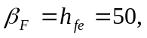 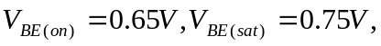
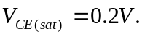 [8]
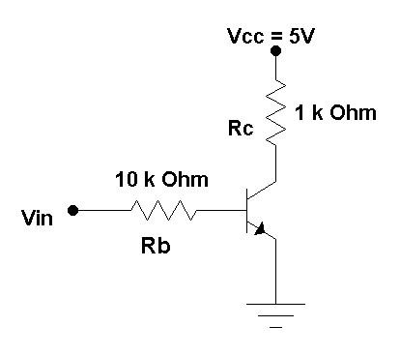
b) Draw the circuit or RTL NOR gate and explain its operation. [7]
- a) Derive the expression for fan out for the standard DTL NAND gate[7]
- The output of the gate V_{o2} is to be fanned out to N similar gates. Find N at room temperature if the ∆1 noise margin is to be 0.3V. [8]
Given: Rc2 = 360Ω; Re = 1.8KΩ; RE = 940Ω; VEE = -5.7V
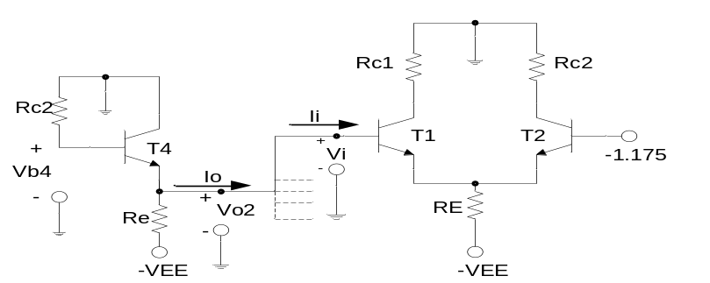
- a) The TTL gate is shown in figure. Explain its operation.[5]
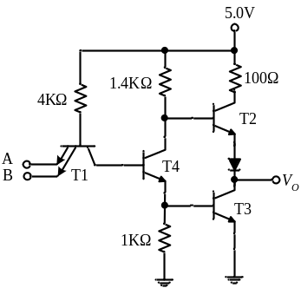

- Write a structural VHDL program to model a 4:1 multiplexer. [5]
- Explain VHDL realization of a full adder. [5]
- a) Discuss the various styles of modelling used in architecture body of hardware description in VHDL. [8]
- How the refreshing action is performed in DRAM? Why it is needed? [7]
- a) Compare CCD with CMOS memory devices. [7]
- For an NMOS inverter, find the critical points on voltage transfer characteristics. [8]
- a) The OR output of the ECL gate is shown below to be fanned out to N similar gates. Find N at room temperature if the ∆1 noise margin is to be zero. Assume that the resistors of driving stage are 10% higher than typical and the resistors of driven stages are 10% lower than typical. The supply voltage is 5% higher and the transistor have current gains, h_{FE} = 60. (The departures from the typical values are all in the direction to reduce the fan-out).The typical values are R_{C2} = 300Ω, R₄ =1500Ω, R_{e} =1180Ω, and V_{EE} =5.2 V. [8]

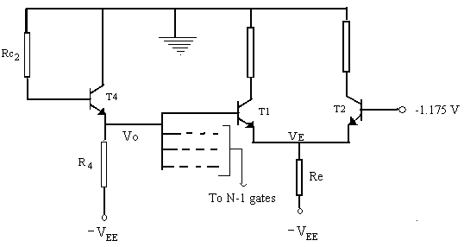

b) Design CMOS NAND & NOR gate for 2 bit inputs. [7]
- Write short notes on any two: [2x5]
- High Threshold Logic
- Active Pull UP.
- Programmable and erasable ROMs
- Twisted pair termination

